Changes in this version:
- New SOP template
- New labelling
- Etc…

INTRODUCTION/PURPOSE
Standard procedure for isolation of DNA using a standard CTAB procedure.

NECESSARY SAFETY EQUIPMENT
 | Nitrile |  | Fume hood

Chemical and biological hazards

Chemicals
Chemical information | Health -, Precautions - and Emergency planning
2% CTAB Buffer  A4150 (Applichem lifescience) supplied by VWR | H319: Causes serious eye irritation  P280: Wear protective gloves/ eye protection/ face protection.  P305+P351+P338: IF IN EYES: Rinse cautiously with water for several minutes. Remove contact lenses if present and easy to do – continue rinsing  P337+P313: If eye irritation persists get medical advice/attention.
2-Mercaptoethanol  M3148 from Sigma Aldrich (MSDS)  CAS no: 60-24-2  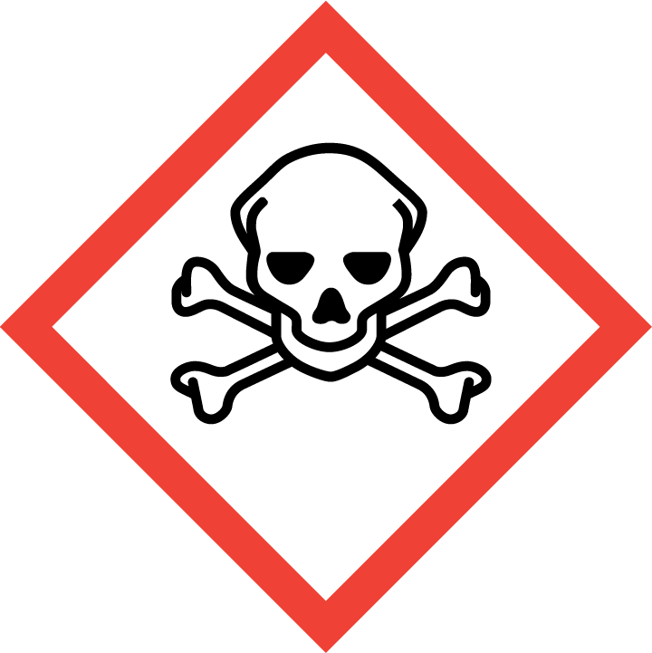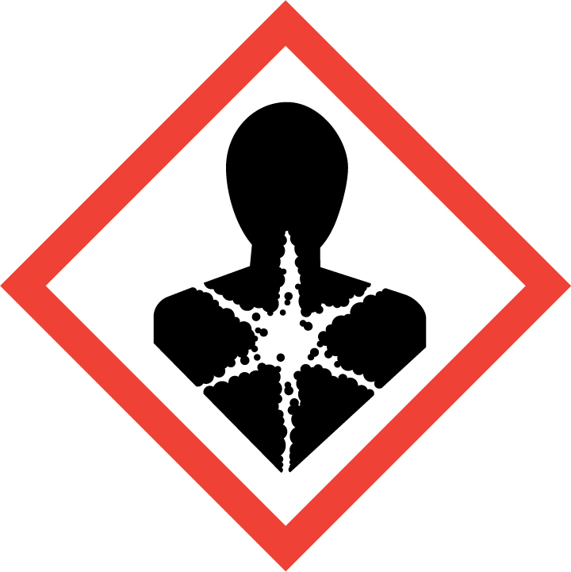  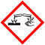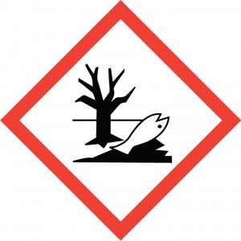 | H301 + H331: Toxic if swallowed or if inhaled  H310: Fatal in contact with skin.  H315: Causes skin irritation.  H317 May cause an allergic skin reaction.  H318 Causes serious eye damage.  H373 May cause damage to organs (Liver, Heart) through prolonged or repeated exposure if swallowed.  H410 Very toxic to aquatic life with long lasting effects.  P261: Avoid breathing vapours.  P273: Avoid release to the environment.  P280: Wear protective gloves/ eye protection/ face protection.  IF SWALLOWED: Immediately call a POISON CENTER or doctor/ physician. IF ON SKIN: Gently wash with plenty of soap and water.  IF IN EYES: Rinse cautiously with water for several minutes. Remove contact lenses, if present and easy to do. Continue rinsing.
Chloroform  Sigma Aldrich/ VWR (MSDS)  CAS no: 67-66-3 | H302: Harmful if swallowed.  H315: Causes skin irritation.  H319: Causes serious eye irritation.  H331: Toxic if inhaled.  H336: May cause drowsiness or dizziness.  H351: Suspected of causing cancer.  H361d: Suspected of damaging the unborn child.  H372: Causes damage to organs through prolonged or repeated exposure.  P261: Avoid breathing vapours.  P281: Use personal protective equipment as required.  IF IN EYES: Rinse cautiously with water for several minutes. Remove contact lenses, if present and easy to do. Continue rinsing.  Call a POISON CENTER or doctor/ physician.
Isopropanol  Sigma Aldrich/ VWR (MSDS)  CAS no: 67-63-0  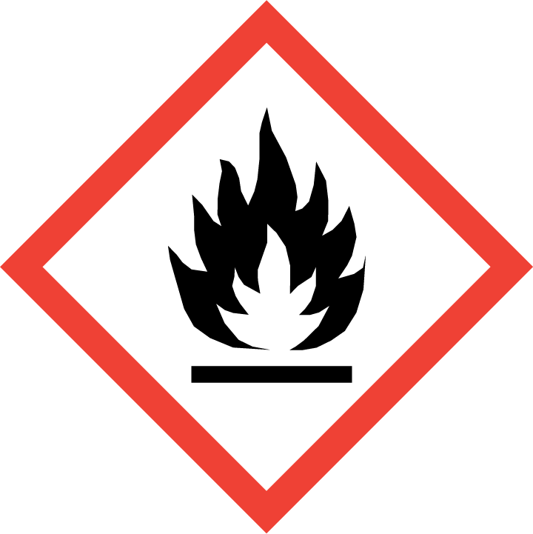 | H225 Highly flammable liquid and vapour.  H319 Causes serious eye irritation.  H336 May cause drowsiness or dizziness.  P210 Keep away from heat, hot surfaces, sparks, open flames and other ignition sources. No smoking.  P261 Avoid breathing vapours.  IF IN EYES: Rinse cautiously with water for several minutes. Remove contact lenses, if present and easy to do. Continue rinsing
70-75%EtOH (diluted from 96%)  Kemetyl (from Sentrallageret)  CAS no: 64-17-5 | H225 Highly flammable liquid and vapour.  H319 Causes serious eye irritation  P210 Keep away from heat, hot surfaces, sparks, open flames and other ignition sources. No smoking.  P261 Avoid breathing vapours.  IF IN EYES: Rinse cautiously with water for several minutes. Remove contact lenses, if present and easy to do. Continue rinsing

Biological Agents
If you are working with biological hazard you should use this table and information from the PSDS. If not cut out

Biological agent | Laboratory hazards, necessary precautions and emergency planning
Neisseria gonorrheae  Risk Group 2  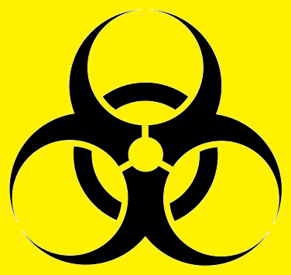 | Containment Level 2 facilities is required  Reported laboratory acquired infections:  - Gonococcal conjunctivitis (eye)  - Cutaneous infections (skin)  The bacteria are mostly known for causing Genital gonorrhoeae  Wear safety goggles, lab coat and gloves.  Avoid contact with contaminated gloves  Wash hands after work  If exposed seek medical assistance.

Special cautions necessary due to reproductive toxicity
Generally, it is not recommended to work with a chemical that has carcinogenic or reproductive effects if you are planning to be or are pregnant. If a chemical is proven to pass into breast milk it is not recommended to perform procedure if you are breast feeding.

If you are working with Class II biological agents that may cause infections, you should consider the risks using the relevant PSDS and other relevant documentation.

Planning pregnancy (men and women): Not recommended to perform this procedure.
Pregnant: Not recommended to perform this procedure.
Breast feeding: None.

PROCEDURE and risk assessment
Necessary equipment:
Pipettes
Pipet tips, assorted sizes
Eppendorf tubes (2 and 1,5mL)
Micro Centrifuge
Mixer Mill / TissueLyzer
Crushing beads
Heating Block

Optional: Preparing 2%CTAB buffer with 2-mercaptoethanol. The 2% CTAB that we buy does not contain 2-Mercaptoethanol; you have to add this yourself.

Remember to wear gloves and lab coat and perform the procedures in the fume hood.
- Pour 50mL 2%CTAB buffer into a 50mL Falcon tube.
- Add 100µL 2-Mercaptoethanol
- Close the lid thoroughly and invert the tube a few times to mix.
- Wrap the tube in alu-foil and label the tube with contents, your name and date.
Tube should be stored in fume hood or ventilated chemical cabinet prior to use

Part of procedure | Unwanted scenarios | Necessary precautions | S*K  (Probability*Consequence)
1 | Spillage of hazardous chemical | Wear gloves, goggles and lab coat | 2*2
2-3 | Spillage of chemical  Inhalation of chemical | Wear gloves and lab coat  Use fume hood | 2*3
4 | Inhalation of chemical | Store in ventilated cabinet/fume hood | 2*1

NOTE: If 2-ME is NOT INCLUDED in the CTAB buffer the overall risk of this procedure will be greatly reduced. Then Chloroform will be the most hazardous chemical in this procedure and steps 1-4 will have a S*K=1*1.

DNA Isolation

Notes:
- Work as sterile as possible. Change gloves whenever necessary.
- Always include a negative control.
- Before starting; preheat the heating block to 65ºC

- The material is placed in 2mL eppendorf tubes and 600µl of 2%CTAB buffer is to be added.
- Grind the material. Usually we grind the material using the Retsch MM200 mixer mill. Add 1-2 tungsten-carbide beads to each 2mL tube and grind for 1min at 20-30 Hz, flip the racks and repeat for 1min.
- Place in -80ºC freezer for minimum 10 min. The material can stay in the -80ºC freezer overnight (or longer).
- Incubate the mixture for 30-45 min. at 65ºC. Invert the tubes 2-3 times during incubation. This step lyses the cells.

5-8 | Spillage and inhalation of solution | Wear gloves and lab coat  Work in fume hood  Incubation in fume hood | 2*3 or 2*1 Depending on 2-ME addition?

- Allow the mixture to cool, add 600µl chloroform to each tube and vortex vigorously.
- Centrifuge the mixture for 15 min at full speed (13200 rpm). You can prepare the tubes being used in step 7 while you are waiting. Put them in the fridge to keep them cool once you are done adding the isopropanol. Be careful when taking the tubes out from the centrifuge so that the two layers don’t mix again.

9-10 | Spillage and inhalation of solution | Wear gloves and lab coat  Work in fume hood  Centrifugation in fume hood | 2*3

- Pipet 400 µl of the upper layer (mainly water and DNA) into new 1.5mL tubes containing 400µl of cold isopropanol. Remember to mark the tubes. Be careful not to get any of the lower layer as this includes the chloroform, among others and may contaminate further steps.

11 | Spillage and inhalation of solution | Wear gloves and lab coat  Work in fume hood | 2*3

- Invert the tubes and allow the DNA to precipitate for min. 10 minutes. You can place the tubes in the fridge (~4ºC) overnight.
- Centrifuge at full speed for 10 minutes.
- Carefully pour off the isopropanol and add 300µl cold 70-75% ethanol. Vortex.
- Centrifuge at full speed for 2 minutes.

14-15 | Spillage and inhalation of solution | Wear gloves and lab coat | 2*1

- Carefully pour off the ethanol. Place to tubes on the heating block (60°C) with the lids open until everything has evaporated. To check that there is no ethanol residue, close the tubes and flick them. If you don’t see any drops on the walls of the tubes it is dry.

16 | Spillage and inhalation of solution | Wear gloves and lab coat | 2*1

- Add 60µl of milli-Q H2O to re-suspend the DNA. If you are purifying your DNA with any method, you should check whether to use water for this step or some other buffer.
- Your DNA is now isolated! Store at –20°C. Remember to label your tubes properly with one label on the side of the tube and the extr. ID written on the lid.

Waste management
Waste type |  | Approx volume | Disposal method | Environmental risk
1 | Tips and gloves contaminated with hazardous chemicals | - | Leave in fume hood to evaporate.  Dispose in hazardous waste box. | None, since this is according to procedure and handled by trained staff and collected by professionals.
2 | Hazardous chemical leftovers | 50mL | Pour into 50mL falcon or other appropriate container.  Leave in fume hood to evaporate. | None, since this is according to procedure and handled by trained staff and collected by professionals.
3 | Non-hazardous chemical leftovers | 50mL | Pour into 50mL falcon or other appropriate container. | None, since this is according to procedure and handled by trained staff and collected by professionals

