Changes in this version:
- New SOP template
- New labelling
- Etc…

INTRODUCTION/PURPOSE
This is a procedure including a detailed risk assessment for making 6 % Perchloric acid. 6 % Perchloric acid is used for EtOH concentration determination.

NECESSARY SAFETY EQUIPMENT
 | Nitrile |  | Fume hood

CHEMICAL AND BIOLOGICAL HAZARDS

Chemicals
Chemical information | Health -, Precautions - and Emergency planning
Perchloric acid 70%  311421 from Sigma  CAS no: 7601-90-3  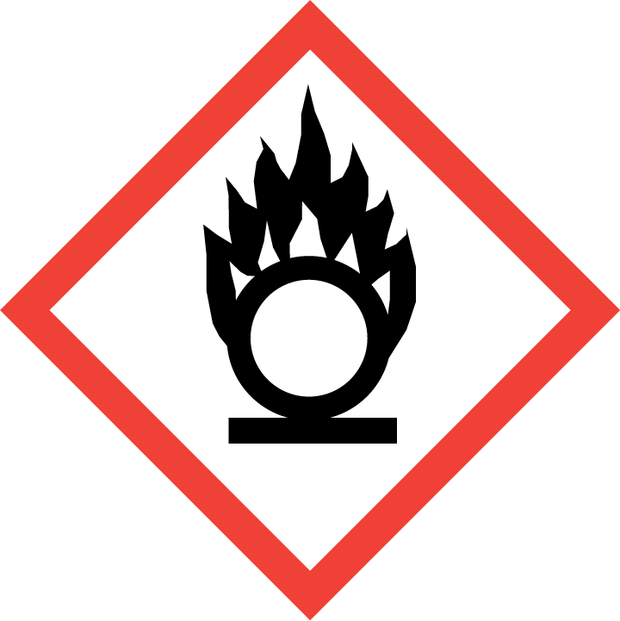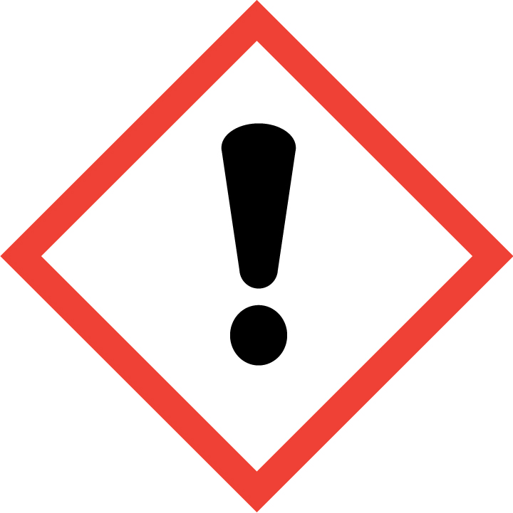  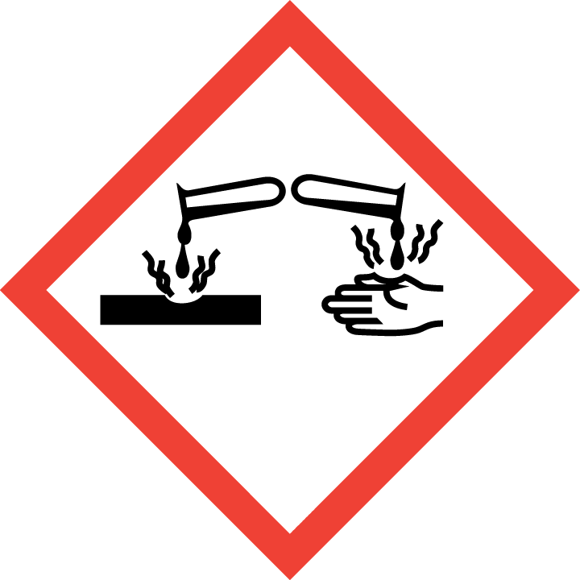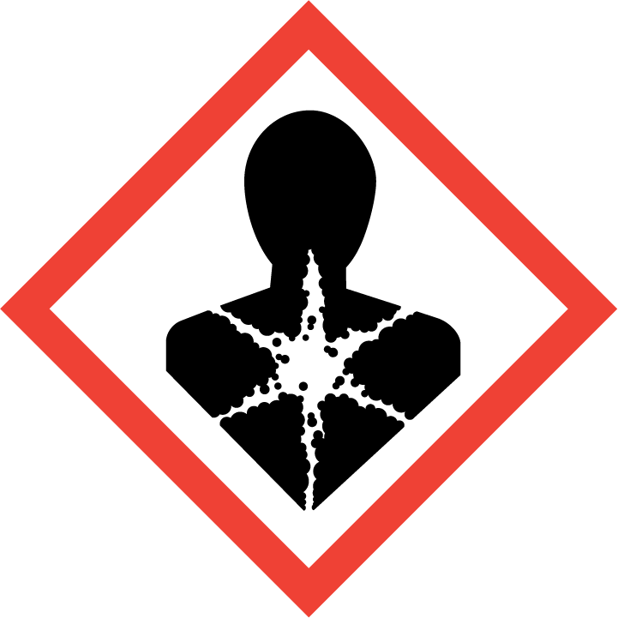 | H271: May cause fire or explosion; strong oxidiser  H290: May be corrosive to metals  H302: Harmful if swallowed  H314: Causes severe skin burns and eye damage  H373: May cause damage to organs through prolonged or repeated exposure  P210: Keep away from heat, hot surfaces, sparks, open flames and other ignition sources. No smoking.  P280: Wear protective gloves/ protective clothing/ eye protection/ face protection.  P303 + P361 + P353: IF ON SKIN (or hair): Take off immediately all contaminated clothing. Rinse skin with water/shower.  P304 + P340 + P310: IF INHALED: Remove person to fresh air and keep comfortable for breathing. Immediately call a POISON CENTER or doctor/ physician.  P305 + P351 + P338: IF IN EYES: Rinse cautiously with water for several minutes. Remove contact lenses, if present and easy to do. Continue rinsing.  P371 + P380 + P375: In case of major fire and large quantities: Evacuate area. Fight fire remotely due to the risk of explosion.

Special cautions necessary due to reproductive toxicity:
Generally, it is not recommended to work with a chemical that has carcinogenic or reproductive effects if you are planning to be or are pregnant. If a chemical is proven to pass into breast milk it is not recommended to perform procedure if you are breast feeding.

Planning pregnancy (men and women): None
Pregnant: None
Breast feeding: None.

PROCEDURES and risk assessment

Procedure
Necessary equipment:
Pipettes
Pipet tips, assorted sizes
50 ml glass bottle
MQ water
Magnetic stirrer

We always wear lab coat when working in the lab.

- Add approx. 40 ml with dH₂O to a 50 ml glass bottle.
- Transfer 4.3 ml 70 % perchloric acid to a 50 ml glass bottle.
- Adjust the volume to 50 ml with dH₂O (6 % perchloric acid).

Part of procedure | Unwanted scenarios | Necessary precautions | S*K  (Probability*Consequence)
1-3 | Spillage of hazardous chemical | Wear gloves, goggles and lab coat. Work in fume hood  Add most of water before adding the acid  Locate nearest fire extinguisher | 2*3

- Mix on magnetic stirrer.
- Label the bottle with 6 % Perchloric acid and hazard symbol according to the risk conclusion , date and your name and store in the fridge.
4-5 | Spillage of hazardous chemical | Wear gloves, goggles and lab coat. Work in fume hood | 2*2

Labelling of new solution:
Please find relevant classification information from existing msds or confer with the ECHA guide for the correct classification and labelling of the solution (this might be quite time consuming).

Perchloric acid 6%  (Information from Sigma 34288) | H315: Causes skin irritation.  H319: Causes serious eye irritation  P280: Wear protective gloves/ protective clothing/ eye protection/ face protection.  P305 + P351 + P338: IF IN EYES: Rinse cautiously with water for several minutes. Remove contact lenses, if present and easy to do. Continue rinsing.  P337 + P313 I If eye irritation persists: Get medical advice/ attention.

WASTE DISPOSAL
When making this solution some waste is generated. It is important to access the potential risk this on the environment and how this waste should be handled.

Waste |  | Volume | Disposal method | Environmental risk
1 | 70 % perchloric acid  Disposal of chemical; too much volume taken out from bottle, the stock solution of 70% perchloric acid is out of date etc. | 0.1 – 100 ml | See chemical waste procedyre (Farlig avfall) | Chemicals for disposal are collected twice a year. According to procedure and handled with trained staff and collected by professionals.
2 | Contaminated disposables or small chemical spillage with 70% perchloric acid; | 0.1 – 1 ml | Risk waste | The risk waste is handled by professionals
3 | 6 % perchloric acid  Rest of solution that is too old.  Rest for using solution to measure EtOH concentration | up to 50 ml | Risk waste  This is rescribed in separate SOP | -

REFERENCES

