Real time assessments of placental size; development of new diagnostic technology (PLAVO Study):
In the search for more knowledge about the placenta
  - Normal placental growth is crucial for the appropriate development of the child, says Professor Anne Eskild. She and her colleagues are in the process of identifying methods to measure placental development during pregnancy, enabling improved detection of high-risk pregnancies.
The placenta can provide information about the child`s health. Researchers at Ahus are currently working on developing methods to diagnose abnormal placental growth during pregnancy. Photo: Anne Haga, Ahus
​
Since 1999, placental weight at birth is reported to the Medical Birth Registry of Norway. Using these data, researchers at Akershus University Hospital (Ahus) have identified an association between abnormal placental size at birth and high-risk pregnancies.
Disproportionality of placental weight and birthweight of the infant is associated with increased risk of fetal death, infant mortality, and cerebral palsy, says project leader and Professor Anne Eskild at Ahus.
Both high and low placental weight are associated with increased risk. These associations are documented by five PhD theses at the Obstetrics and Gynecology Research Group, Ahus, highlighting the need to monitor placental size and growth during pregnancy.
​
Anne Eskild is a senior consultant at Ahus and a professor at the University of Oslo.

Lack of measurement methods
Now there are no valid methods to measure placental size in ongoing pregnancies. Being able to diagnose abnormal placental growth during pregnancy, would allow preventive measures. This could save fetuses from death and children from death or disability, says Anne Eskild.
However, measuring placental size while it is still in the uterus is not straightforward. Currently, there is no reliable method to measure placental size during pregnancy, and little is known about the normal variation in placental growth or shape during pregnancy. ​

Testing new methods
Therefore, researchers at Ahus established the PLAVO study (The Placental Volume Study) in 2018/2019 to develop and test various methods for measuring placental volume. The study recruited 250 women to be examined with ultrasound and MRI up to three times during pregnancy.
What is normal placental growth and what is the variation in placental shape are among the research questions in the PLAVO study.
We have found that three-dimensional ultrasound is not currently a good enough method for measuring placental volume. However, presently we are collaborating with SINTEF Digital to develop a better ultrasound method, Eskild says.
Ultrasound is routinely used for diagnostics in pregnancy. MRI is expensive and rarely used for diagnostics in pregnancy. However, the researchers have developed a method to quickly calculate placental and fetal volume during MRI examinations. This involves the application of artificial intelligence and machine learning of MRI images. The research group has used MRI images to calculate placental size and create percentiles for placental growth inside the uterus.

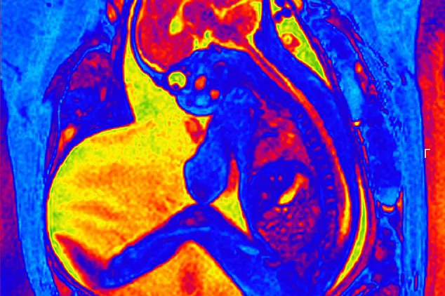
MRI image of a fetus in the uterus.
Based on these data, we are comparing placental size inside the uterus with placentas that are delivered at the same gestational age.
The research group is also studying whether simple 2D ultrasound measurements can provide information about placental size.
Additionally, the project is developing MRI methods to measure blood flow in the placenta. The researchers are investigating whether there is an association between placental size and blood flow to the fetus and from uterus to the placenta.

Facts about the PLAVO Study ​​
About the project: The Placental Volume Study (PLAVO) is an ongoing project that started in 2018. It is led by the Women's Clinic at Ahus, in collaboration with the Division of Diagnostic Imaging and Technology (Ahus), the University of Oslo, and SINTEF Digital.
About the field: Using data from the Medical Birth Registry on placental weight at birth in all pregnancies in Norway in the years after 1999, five doctors at the Women's Clinic have defended- their PhD thesis’s showing a correlation between placental weight at birth and high-risk pregnancies. Currently, there is no reliable diagnosis of placental size in ongoing pregnancies, and the normal variation in placental growth is unknown. The PLAVO study aims to develop methods to learn more about this.
About the research group: Project leader Anne Eskild (Ahus, UiO), postdoc Vigdis Hillestad (HSØ, Ahus), Helene Fjeldvik Peterson, Karianne Sagberg, Silje Sommerfelt (all: Ahus, UiO Phd students). Arne Borthne (Ahus, UiO), Kjell-Inge Gjesdal (Ahus), Heidi Hamil Gorman (Ahus, Oslo-Met, PhD student), Lars-Eirik Bø, and Torgim Lie (both SINTEF Digital). Lucy Higgins (University of Manchester, UK).

Publications: (dated 21st of Descember 2023)
Karianne Sagberg, Anne Eskild, Silje Sommerfelt, Kjell I Gjesdal, Lucy E Higgins, Arne Borthne, Vigdis Hillestad (2021). Placental volume in gestational week 27 measured by three-dimensional ultrasound and magnetic resonance imaging. Acta Obstet Gynecol Scand. 2021;100:1412-1418. doi: 10.1111/aogs.14115.
Peterson HF, Eskild A, Sommerfelt S, Gjesdal K, Borthne AS, Mørkrid L, Hillestad V. Percentiles of intrauterine placental volume and placental volume relative to fetal volume: A prospective magnetic resonance imaging study. Placenta. 2022 Apr;121:40-45. doi: 10.1016/j.placenta.2022.02.023. Epub 2022 Mar 1. PMID: 35259595.
Kulseng CPS, Hillestad V, Eskild A, Gjesdal KI. Automatic placental and fetal volume estimation by a convolutional neural network. Placenta. 2023 Mar 24;134:23-29. doi: 10.1016/j.placenta.2023.02.009. Epub 2023 Feb 27. PMID: 36863128.
Kulseng CPS, Sommerfelt S, Flo K, Gjesdal KI, Peterson HF, Hillestad V, Eskild A. Placental size at gestational week 27 and 37: The associations with pulsatility index in the uterine and the fetal-placental arteries. Placenta. 2023 Dec 4;145:45-50. doi: 10.1016/j.placenta.2023.11.014. Epub ahead of print. PMID: 38064937.
Peterson HF, Eskild A, Sommerfelt S, Hillestad V. Placental size at gestational week 36: Comparisons between ongoing pregnancies and deliveries. Acta Obstet Gynecol Scand. 2023 Oct 30. doi: 10.1111/aogs.14700. Epub ahead of print. PMID: 37904568.

