PRACTICAL SKILLS IN GYNAECOLOGY

- Microbiology testing
- Pap smear (cervical smear)
- Insertion of the IUD

9th semester

Skills Center (www.med.uio.no/rh/ferdighetssenteret/)

Responsible for the course: Kristin Langdalen

Approved by lecturer: Gry Findal, MD (Last revided 29.10.13)

General clues

- Inform the patient about the examination and establish a good relationship
- Ensure that you have enough light and a correct working position
- Prepare the instruments and kits before starting the procedure. Do not put dirty hands in the clean containers as you go!
- Write down the patients’ name and ID-number (N-11 numbers) on the microscope slide, test glasses and the patients form (remittance)
- Heat the speculum in a special heater or in warm water
- Put used instruments in a specific container
- GE is a clean procedure –keep clean!
- Installation of the IUD is a sterile procedure –keep sterile!

It is very important to keep the instrument table tidy. Throw all used instruments for one-time use in the dustbin. Instruments that are going to be used again should be put in a suitable container.

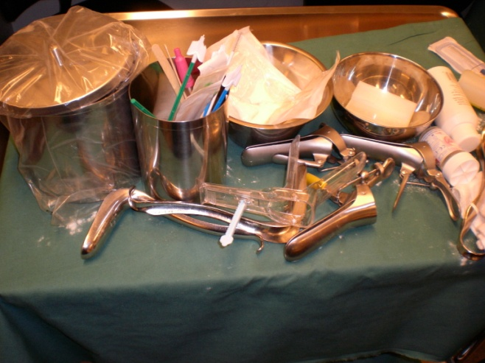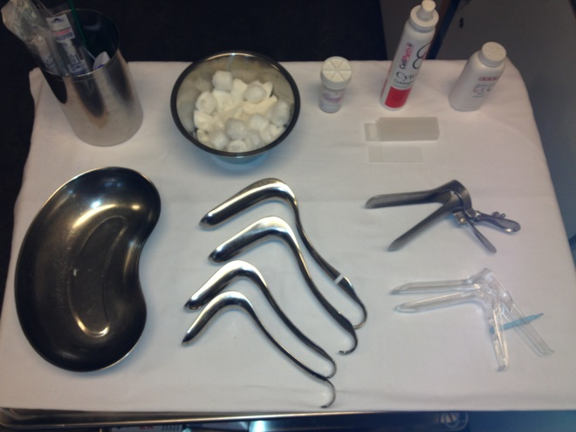
Untidy instrument table –try to avoid this! Tidy instrument table

(Classical) Pap smear

The sample is taken from the transformation zone, where the squamous epithelium meets columnar epithelium. This zone is seen on the portio in young women. In older women, it might be found inside the cervix.
Equipment: - Disposable gloves
- Cusco’s speculum
- Wooden spatula
- Cytobrush
- Microscope slide
- Spray for fixation of the smear
- Transport container

Cytobrush Fixation fluid

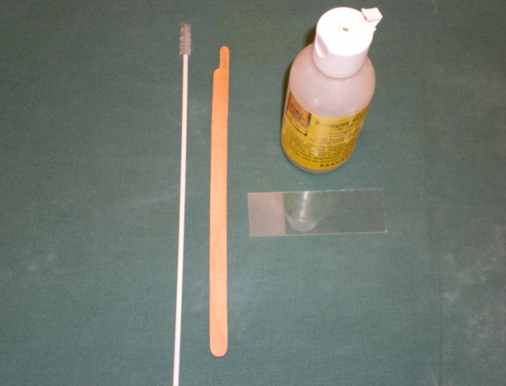

Wooden spatula Microscope slide

Practical procedure

Insert the speculum anteroposteriorly/oblique and rotate as you let it slide inside. Open and fix it.

Spatula: Stroke the thick end around the portio. Place the material on the slide.

Cytobrush: Insert the brush 1 cm up into the cervix and rotate 2 times. Place the material on the slide, using a rolling manoeuvre. Do NOT put the material from the spatula and the cytobrush on top of each other, but on two different sections.
- Fixate the material before it dries up!
- Dry in 20 minutes.
- Put the slide in the transport container, fill in the cytological form and send it to the lab.

Use one slide for all the cytological samples, both from the spatula and the cytobrush.
Be gentle while doing the procedure; blood makes the pap smear almost impossible to analyse!

Liquid-based cytology (LBC)

This is a newer method than the classical pap-smear, and it is becoming more and more popular. Liquid-based cytologi is shown to give the cervical smears better quality; there are lower amounts of uncertain diagnoses and useless samples and increased amounts of high-grade dysplasias. It is also possible to perform HPV-typing on the material.
Equipment: Disposable gloves
Cusco’s speculum
Cervix-broom
Fixation fluid (ThinPrep Pap Test)

Cervix-broom
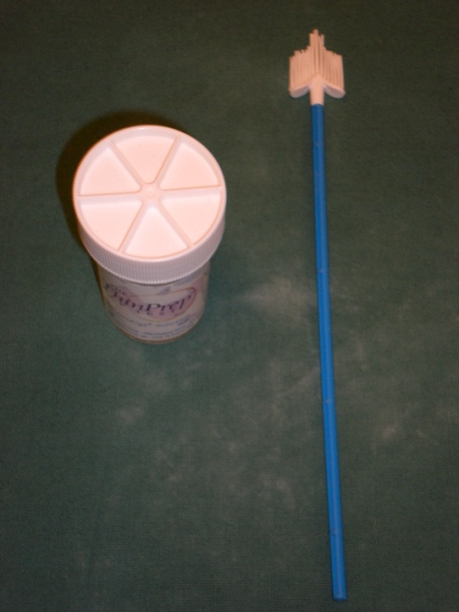

ThinPrep container

Practical procedure
- Insert the speculum anteroposteriorly/oblique and rotate as you let it slide inside.
Open and stabilize it. Avoid using gel.
- Put the cervix-broom into cervix. The brush will take a sample both form portio and cervix. Rotate the brush in one direction with an even and quick movement. Rotate the cervix-broom 8 times. Remove the broom quickly. Avoid bleeding.

- Put the broom in the transport medium immediately, and rub the broom against the container.
The broom must be removed from the container. If not, the cells will become
adherent to the broom.
NB: It is possible to use cervix-broom instead of cytobruch and spatula for the Classical pap-smear

Microbiology testing
Equipment: - Disposable gloves
- Cusco’s speculum
- Stuart’s medium (when testing for anaerobe and aerobe bacteria, Candida and protozoa)
- Chlamydia kit (large swab for removing vaginal discharge, large swab for the cervical test and small swab for sampling from the urethra (mainly in men)

Swab for the cervical test
Swab for removing vaginal discharge

Swab for sampling from the urethra

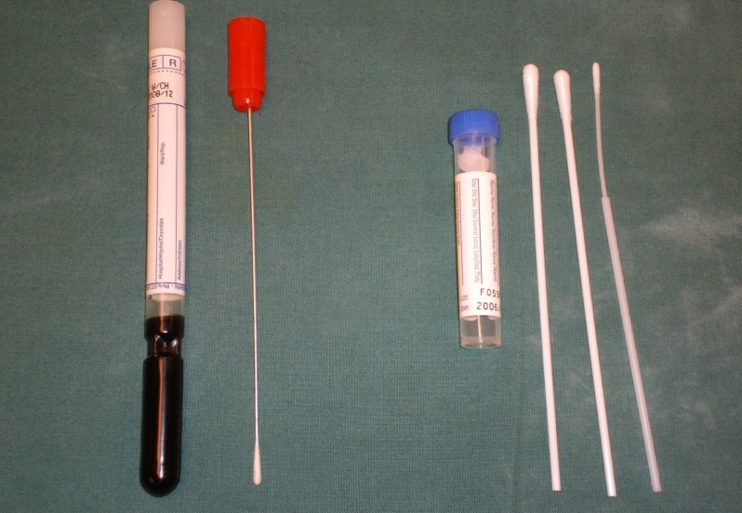

Transport medium, Chlamydia sampling
Swab for bacteriological sampling
Stuart’s medium

Which samples you need to take, will depend on the clinical history of the patient.

Practical procedure:
- Insert the speculum
- Stuart’s medium: Stroke the swab around the portio and make sure that you also get a sample from the posterior fornix, where the bacteria often accumulate. Place the swab into the container.
- Chlamydia: Remove discharge if needed. Insert the large-sized cotton stick 1 cm into the cervix and rotate in about 8 times. Touch the cotton stick at the vaginal wall on the way out. Put the swab in the test glass, and mix before you remove the stick and plug the glass.

Do not use antiseptic gel before microbiology testing! (Use water or gel not containing antiseptics instead).

IUD (IntraUterine Device)

Cu-IUD
Different types:
- Flexi T
- Flexi T+
- Nova T

Mechanism of action: Release of Cu ions changes the environment in the uterus and interferes with the swimming ability of the sperm. Movement of sperm and the implantation is prevented. Pearl Index 1-2.
Side effects: - Menorrhagia
- Dysmenorrhoea
- Increased risk of PID if the patient gets a genital infection
Not associated with cancer or other serious diseases that may be caused by hormonal contraceptives.

Contraindications: - Menstrual problems
- Pathology in the reproductive organs
- Sexual behaviour that indicates increased risk of STD’s
- Bleeding tendency

Gestagen IUD (Mirena)
Combines the effects of the Cu-IUD and the hormone based contraceptives, making it the safest choice of contraception. Pearl Index < 1. The gestagen IUD is also used as treatment for menorrhagia, because it significantly reduces the menstrual bleeding.
Mechanism of action: Stimulates the mucus plug in the cervix and keeps the endometrium thin and in hostile for the zygote; the movements of sperm and the implantation of the zygote are inhibited. In addition, some ovulations are inhibited.
Side effects: - Reduced menstrual bleeding (20 % of the patients have amenorrhea after 6 months.
- Systemic effects of gestagen such as acne, oily scalp and mood changes.
- Slightly reduced risk of PID because of the mucus plug.

Contraindications:
- Pathology in the reproductive organs
- Sexual behaviour that indicates increased risk of STD’s
- Breast cancer in the patient or close relatives.

Insertion
Most women feel uncomfortable during the procedure, some think it is painful, and a few experience vasovagal reactions. In the 2-3 days following the procedure, pain and discomfort is often reported.

Complications after the installation:
- Perforation. Happens in 0,1-0,5 % of the patients. Largest increase in risk the first 3 months after giving birth.
- PID associated with the installation. The risk decreases when using correct technique and screening for infection before insertion. The risk of infection is said to be increased only the first month after installation of the IUD.

The IUD lasts for 5 years. Inform the patient to regularly feel for the threads because the IUD sometimes falls out unnoticeable.

Advice the patient to go to the doctor if:
- She experiences abdominal pain, fever and vaginal discharge
- She cannot feel the threads
- She experiences persistent bleedings and pain
- Absent menstruation (pregnancy?)

Equipment: - Disposable gloves
- Surgical gloves
- Speculum
- Klorhexidin
- IUD
- Sterile kit for installing IUD: - Sterile container
Cusco’s speculum
- Jacob’s tenaculum
- Gynaecological tongs
- Scissors
- Sterile tupfers
- Sonde

Speculum Jacob’s tenaculum

Tongs Uterin sonde
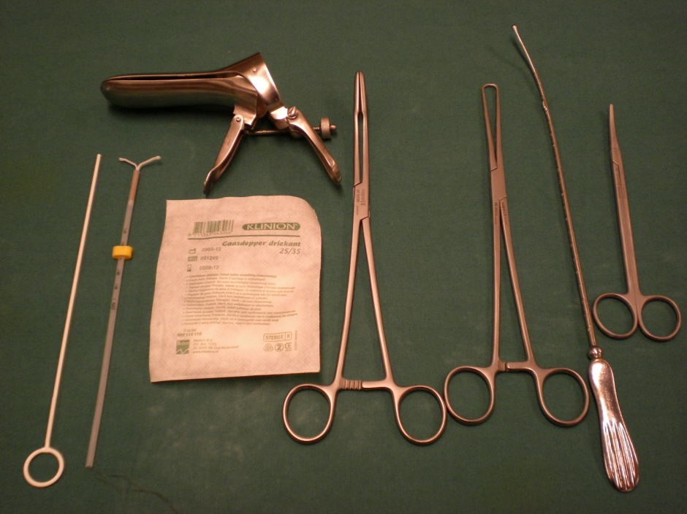

IUD Sterile tupfers Scissors

Practical procedure
- Put on disposable gloves, and perform a bimanual palpation. How is the size and position of the uterus? Signs of infection? Pathology?
- Open the covering containing the IUD, without touching the IUD.
- Read the instruction manual!
- Pour klorhexidin and tupfers into the sterile container.
- Put on sterile gloves.
- Prepare the IUD: Stabilize the wings against a flat sterile base to make sure they are lying horizontally when you pull them into the straw.
- Insert and fix the sterile speculum.
- One must be careful not to touch the vagina opening with gloves, and if so, make sure one hand remains sterile at all time, and not touch the parts of the IUD that will be inserted into the uterus.
- Wash the vagina and portio with klorhexidin. Use 3-4 tupfers, and wash only one time around the portio with each tupfer.
- Fixate the Jacob’s tenaculum at the portio, in the 12 o’clock position, and pull the cervix gently towards you.
- Measure the size of the uterus by using the sonde registrating humidity, and set the ring according to the measurement. You can also set the ring directly, according to the bimanual palpation, without the use of the sonde. In such cases: Set the ring at 8 cm.
- Pull the cervix towards you as you insert the IUD without touching the speculum or vaginal walls.
- Let it slide inside the uterus until you feel resistance and the yellow stopper is touching the portio. Then pull the IUD 1 cm towards you and release the wings using the stamp.
- Remove the stamp first, then remove the straw.
- Cut the threads 2-3 cm outside the portio.
- Open the tenaculum, close it and remove it.
- Remember to keep sterile during the procedure!

